Methods

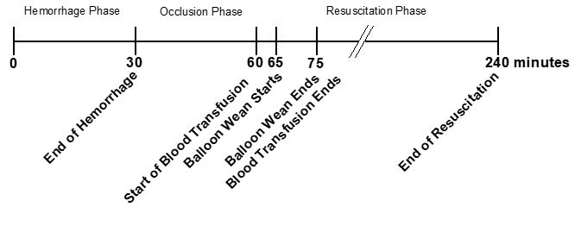
Figure 1. Experimental timeline

Statistical Analysis
- Evaluate Hemodynamic Changes During Hemorrhage:
  - Perform a two-way ANOVA to assess differences in mean hemodynamic vitals between baseline and the end of hemorrhage.
  - Adjust the analysis for potential covariates including
  - sex, weight, basal norepinephrine rate, and possibly basal isoflurane percentage.
- Analyze Covariate Effects During Balloon Wean:
  - Investigate the impact of sex, weight, norepinephrine dose, and HES (Hydroxyethyl starch) as covariates during the balloon weaning phase.
- Characterize Critical Care Period Trends:
  - Examine expected changes in norepinephrine, vasopressin, and Plasmalyte usage during the critical care period.
  - Identify significant treatment or physiological differences across this timeframe.

Results

Table X (or Figure). Summary of fluid and norepinephrine administration from T30 to T60 minutes. From T0 to T30, no fluids were administered and animals received only basal norepinephrine at a fixed rate. Between T30 and T60, some fluids were introduced, including potential HES boluses, while norepinephrine remained at a constant rate. From T60 to T75, blood was administered along with additional HES and Plasmalyte; norepinephrine dosing may have begun to vary during this period. From T75 onward, animals entered the full critical care phase, during which cumulative fluid and vasopressor volumes were recorded. Key cumulative time points include T120 and T240.

To assess whether the percentage of hemorrhage influenced key perioperative parameters, we performed a series of statistical comparisons across hemorrhage groups. Each variable was first evaluated for normality of residuals using the Shapiro-Wilk test following one-way ANOVA modeling. Variables that failed the normality test (p < 0.05) were instead analyzed using the non-parametric Kruskal-Wallis test.
Four variables failed the Shapiro-Wilk test for normality:
- Instrumentation (min)
- Plasmalyte/Time
- Crystalloids Exp. (mL)
- Heparin (mL)
These were therefore assessed using the Kruskal-Wallis test. The remaining three variables were analyzed using one-way ANOVA.
No statistically significant differences were found between hemorrhage groups for any of the tested variables, regardless of the statistical method applied. Full results are summarized in Table X.

 | Hemorrhage Level |  |  | Comparing all groups within the same time point
 | 10%  (N=18) | 20%  (N=18) | 30%  (N=18) | Test Used | p-value
Pre-baseline (during instrumentation)
Weight (kg) | 62.6 ± 4.4 | 65.2 ± 4.9 | 64.4 ± 4.0 | ANOVA | 0.193
Total Instrumentation time (minutes) | 208 ± 27 | 215 ± 34 | 208 ± 32 | Kruskall-Wallis | 0.5696
Total Plasmalyte volume (L) | 4323 ± 622 | 4724 ± 829 | 4550 ± 611 | ANOVA | 0.231
Total Plasmalyte/time (L/min) | 20.9 ± 3.1 | 22.0 ± 2.7 | 22.1 ± 2.4 | Kruskall-Wallis | 0.3958
Total Norepinephrine (mcg) | 357 ± 135 | 332 ± 191 | 348 ± 169 | ANOVA | 0.901
Total Heparin (mL) | 5.4 ± 0.5 | 6.0 ± 0.4 | 5.8 ± 0.6 | Kruskall-Wallis | 0.265
Isoflurane (%) | 1.8 ± 0.1 | 1.8 ± 0.1 | 1.8 ± 0.2 | ANOVA | 0.244

Table 1. Summary statistics of cardiac and hemodynamic vitals recorded at baseline (start of the experiment) and at the end of hemorrhage (T30). Values are presented as means ± standard deviations. Differences across hemorrhage levels were assessed using two-way ANOVA or the Kruskal-Wallis test when appropriate. Statistical significance was defined as p < 0.05. At T30, the 30% hemorrhage group exhibited a significant reduction in both renal and carotid flow compared to baseline. Additionally, this group had the lowest flow values at T30 when compared to the 10% and 20% hemorrhage groups.

Analysis Method:
- Assess Differences Across Hemorrhage Levels:
  - Use two-way ANOVA to test for statistically significant differences in vitals between hemorrhage levels.
  - Apply the Kruskal-Wallis test as a non-parametric alternative when assumptions of ANOVA are not met.

We compared several cardiovascular and flow-related parameters across three hemorrhage levels (10%, 20%, and 30%) at baseline (T0) and after hemorrhage (T30). Appropriate statistical tests were selected based on normality of residuals: ANOVA for normally distributed data, and Kruskal-Wallis for non-normal data.
At baseline, there were no statistically significant differences across hemorrhage levels for any of the measured parameters, meaning systolic blood pressure (SBP), diastolic blood pressure (DBP), heart rate (HR), cardiac output (CO), and mean arterial pressure (MAP) were all comparable between groups. Likewise, no differences were observed in carotid or renal blood flow rates at baseline.
Following hemorrhage, multiple parameters showed significant differences across hemorrhage levels:
- SBP, DBP, HR, and MAP showed significant group differences, indicating progressive cardiovascular compromise with increasing blood loss.
- CO showed a trend toward significance (p = 0.0585), suggesting some variability but insufficient evidence for a group difference
- Carotid and renal flow rates were significantly reduced with greater hemorrhage levels.

Hemorrhage Level
 | 10%  (N=18) | 20%  (N=18) | 30%  (N=18) | Test Used | p-value
Baseline Vitals (T0)
SBP (mmHg) | 71 ± 14 | 76 ± 7 | 73 ± 7 | Kruskall-Wallis | 0.186
DBP (mmHg) | 4 ± 2 | 4 ± 1 | 4 ± 2 | Kruskall-Wallis | 0.927
HR (bpm) | 97 ± 22 | 94 ± 18 | 105 ± 25 | Kruskall-Wallis | 0.4444
CO (L/min) | 5.2 ± 2.1 | 4.3 ± 1.3 | 5.6 ± 2.0 | Kruskall-Wallis | 0.128
MAP (mmHg) | 57 ± 5 | 61 ± 5 | 58 ± 7 | ANOVA | 0.2
Baseline Flow Rates
Carotid Flow (mL/min) | 286 ± 85 | 309 ± 58 | 277 ± 88 | ANOVA | 0.462
Renal Flow (mL/min) | 215 ± 49 | 253 ± 60 | 230 ± 57 | ANOVA | 0.131
At the End of Hemorrhage (T30)
SBP (mmHg) | 58 ± 9 | 47 ± 8 | 31 ± 13 | ANOVA | 0.0000000011*
DBP (mmHg) | 2 ± 1 | 2 ± 1 | 2 ± 1 | Kruskall-Wallis | 0.0066*
HR (bpm) | 96 ± 15 | 114 ± 27 | 125 ± 27 | ANOVA | 0.0024*
CO (L/min) | 4.6 ± 2.5 | 3.3 ± 1.3 | 3.4 ± 2.7 | Kruskall-Wallis | 0.0585
MAP (mmHg) | 46 ± 5 | 38 ± 6 | 24 ± 7 | ANOVA | 2.23e-14*
Flow Rates at the End of Hemorrhage
Carotid Flow  (mL/min) | 193 ± 57 | 156 ± 53 | 95 ± 54 | Kruskall-Wallis | 6.486e-05*
Renal Flow  (mL/min) | 147 ± 54 | 98 ± 35 | 36 ± 28 | Kruskall-Wallis | 1.713e-07*

Side Tasks:
**compare raw flow data vs. normalized in this table.

Verify renal flow – normalized data – (average seems off for 30% group at T30)

Figure X. Mean normalized carotid flow over time by hemorrhage and aortic occlusion groups. Carotid flow values were normalized to each animal’s baseline. Data are presented as means ± standard deviations from T30 to T90 minutes. Hemorrhage groups are color-coded: 10% (black), 20% (blue), and 30% (red). Occlusion groups are

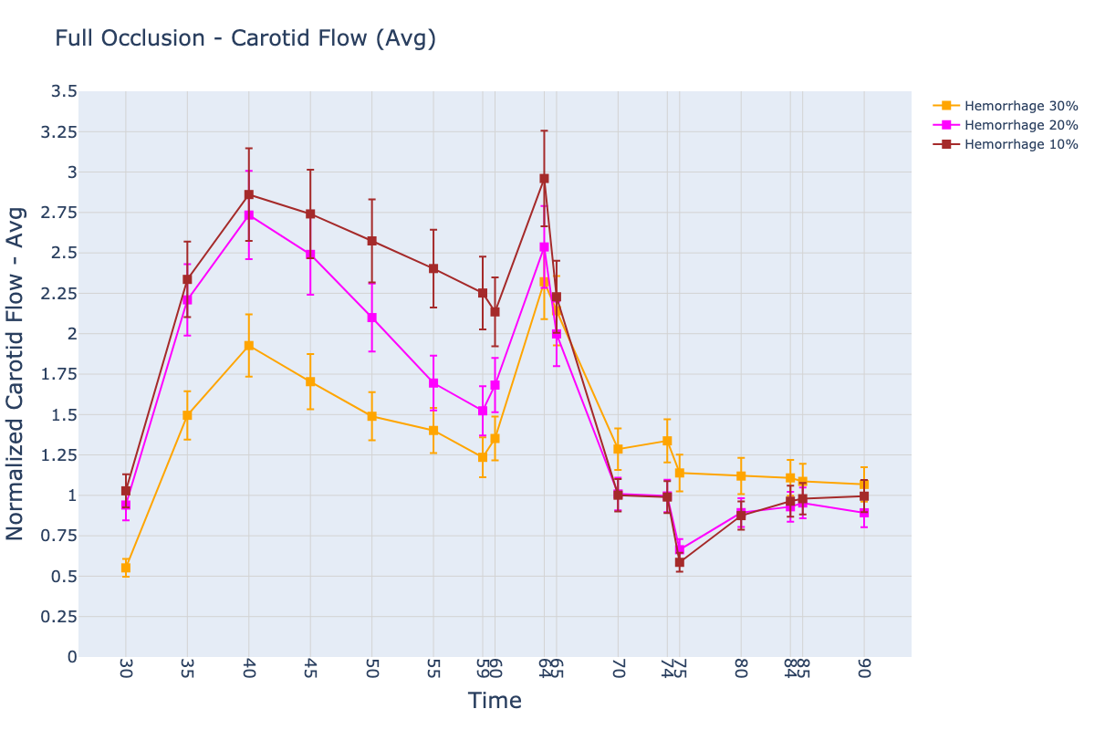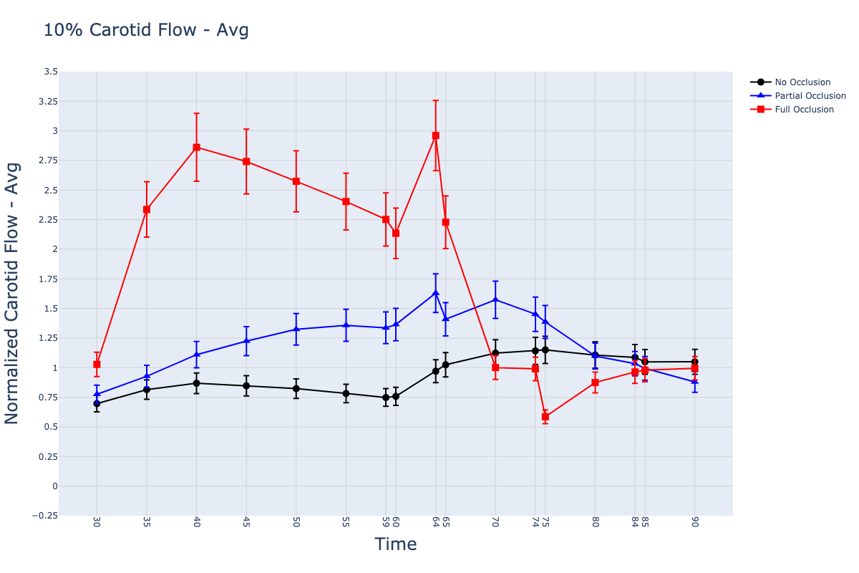

No occlusion | Partial Occlusion | Full Occlusion
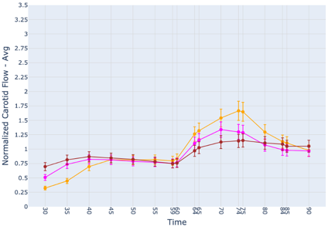 | 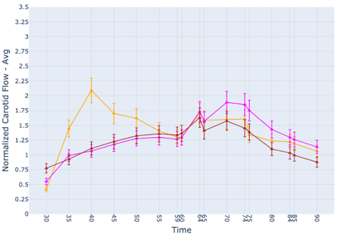 | 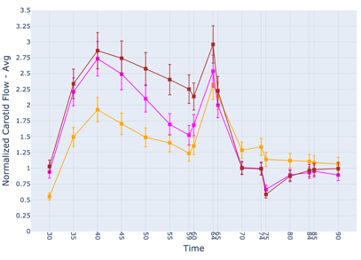
10% Hemorrhage | 20% Hemorrhage | 30% Hemorrhage
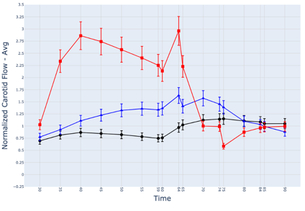 | 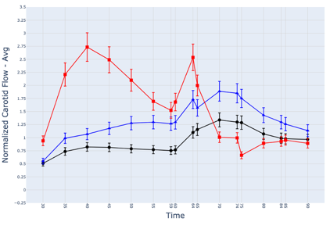 | 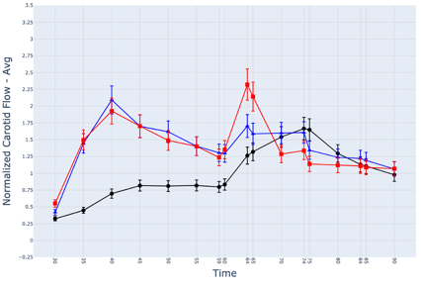

Figure X. Mean normalized renal flow over time by hemorrhage and aortic occlusion groups. Renal flow values were normalized to each animal’s baseline. Data are presented as means ± standard deviations from T30 to T90 minutes. The rate of renal flow restoration was dependent on the level of hemorrhage. Pigs in the 10% hemorrhage group exhibited a rapid return of renal flow, while those in the 30% group required at least 10 to 15 minutes of aortic occlusion before flow was reestablished.

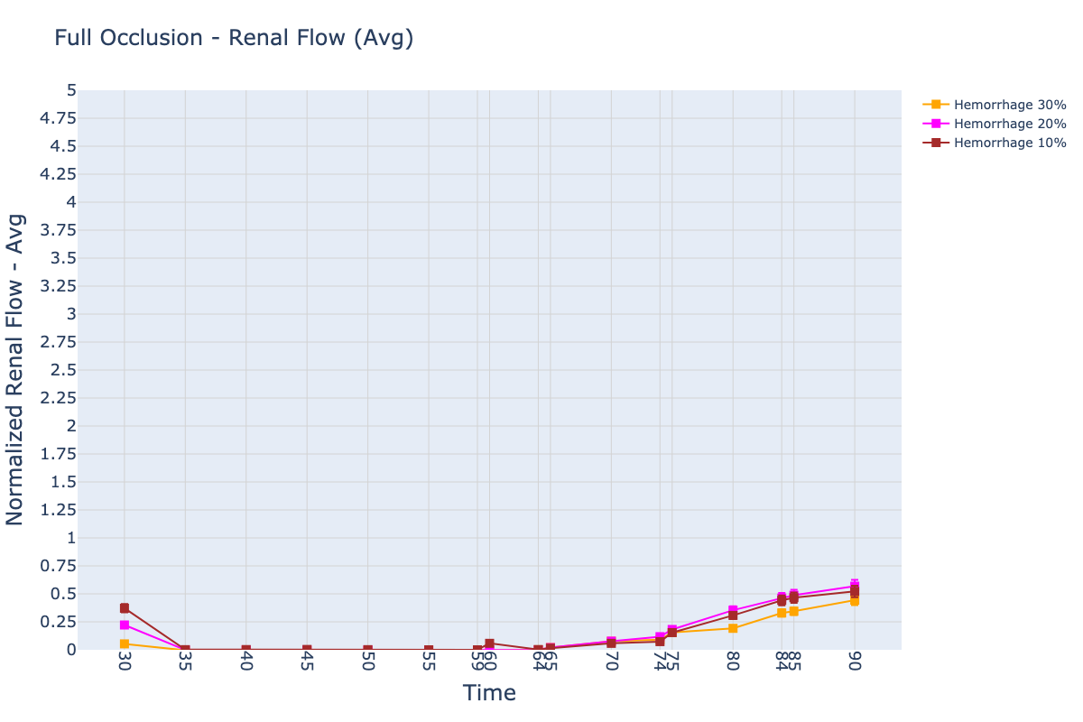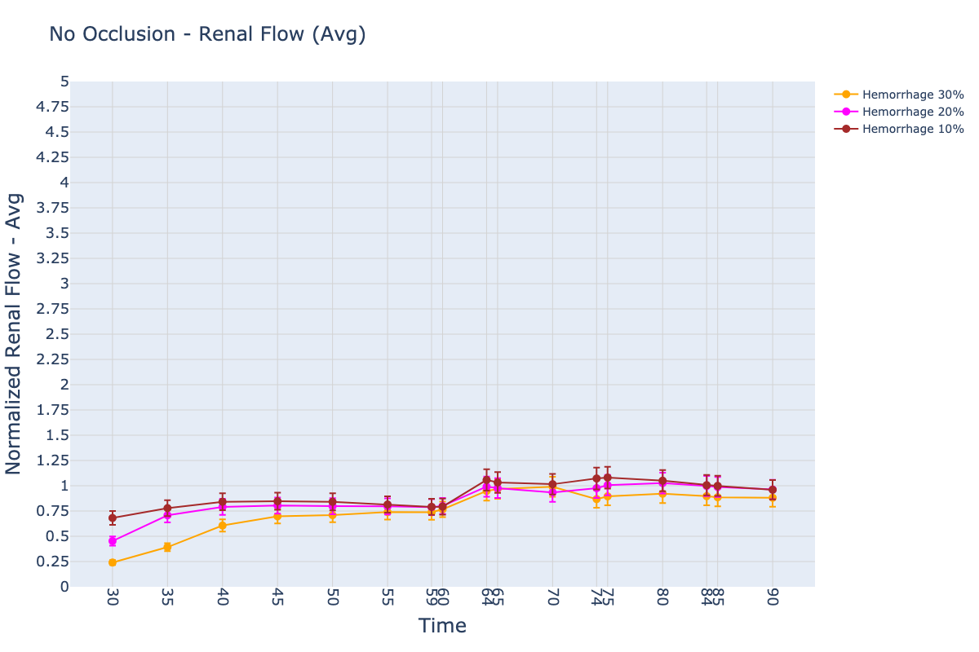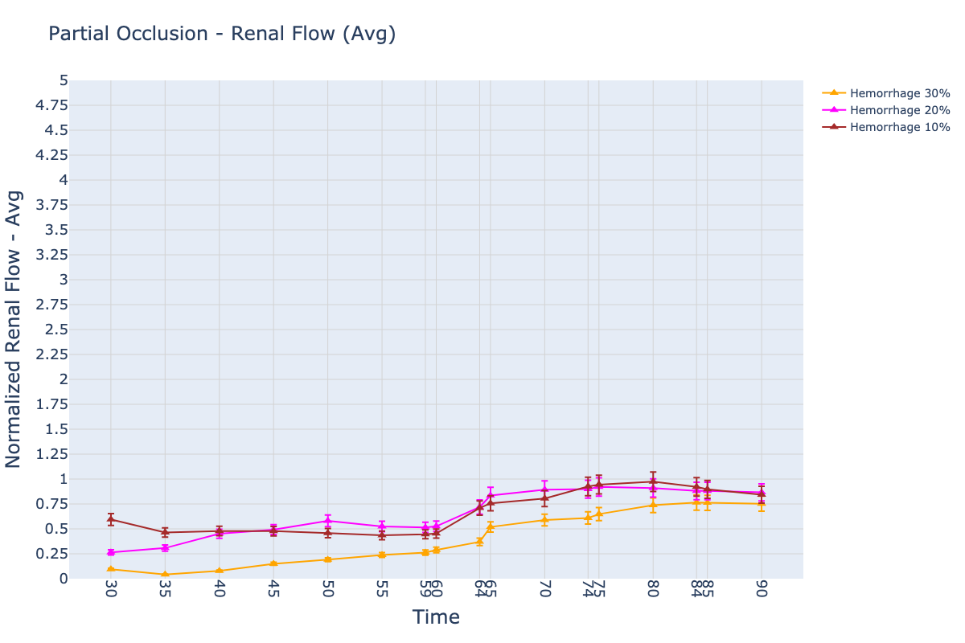


No occlusion | Partial Occlusion | Full Occlusion
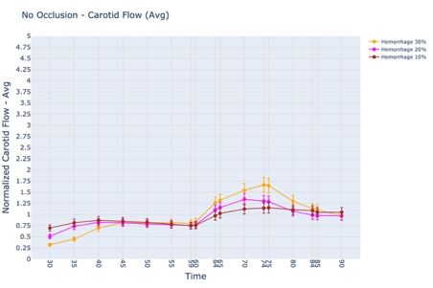 | 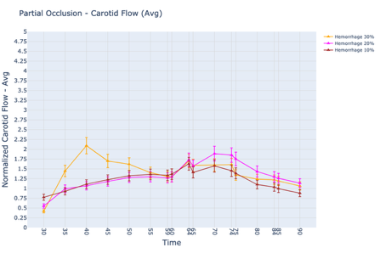 | 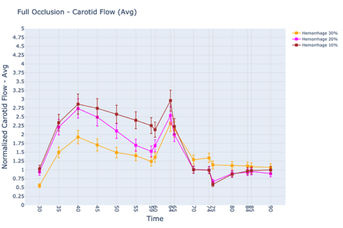
10% Hemorrhage | 20% Hemorrhage | 30% Hemorrhage
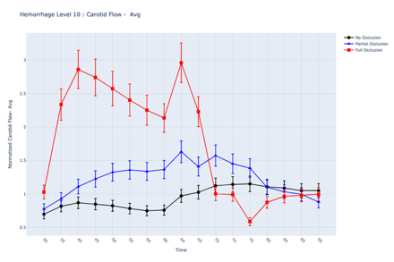 | 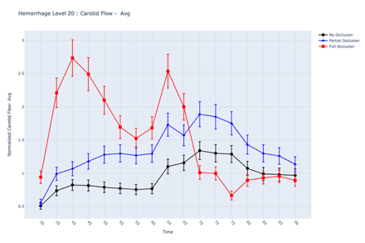 | 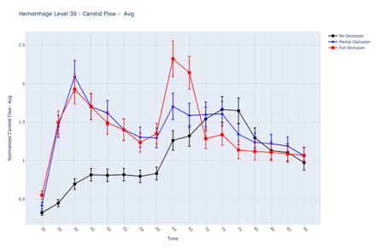

Resuscitation Fluid and Norepinephrine Demand
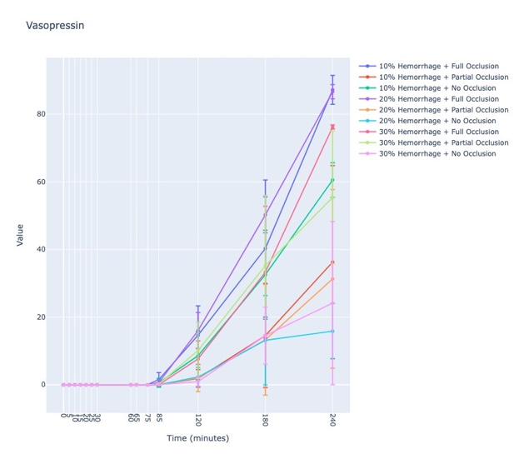 | 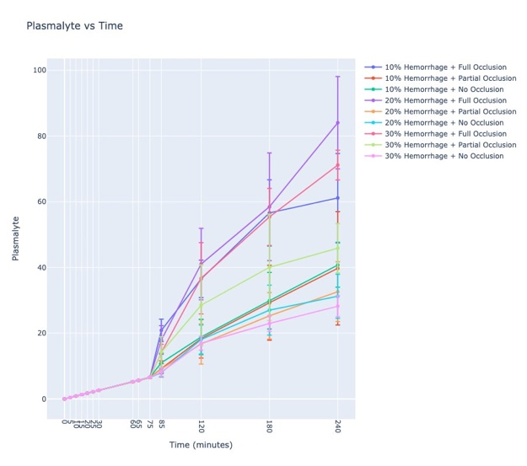 | 